

**ENIN 880CA**

**ADVANCED ARTIFICIAL NEURAL NETWORK**

**PROJECT REPORT**

**FACE MASK DETECTION SYSTEM USING CNN AND TRANSFER LEARNING**

**SUBMITTED TO**

Dr. RENE MAYORGA

PROFESSOR, INDUSTRIAL SYSTEMS ENGINEERING

**SUBMITTED BY**

DHAVAL BHAILALBHAI PATEL [200439819]

VEDANG PANDYA [200427798]

FACULTY OF GRADUATE STUDIES AND RESEARCH

FACULTY OF ENGINEERING AND APPLIED SCIENCES

**INDEX**

* **PROBLEM STATEMENT**
* **AREA OF INTEREST**
* **PROBLEM DEFINITION**
* **CONVOLUTIONAL NEURAL NETWORK**
* **ESSENTIAL LIBRARIES AND TOOLS REQUIRED**
* **PROPOSED ALGORITHM**
* **DATASET**
* **CODE**
* **METHOD 1 – TRAINING CNN FROM SCRATCH**
* **METHOD 2 – REINFORCEMENT LEARNING ON GOOGLE MOBILENET-V2**
* **ANALYTICS ON THE DATA GATHERED FROM PREDICTIONS**
* **COMPARISON OF PROPOSED NEURAL NETWORK VS MOBILENET-V2**
* **FUTURE WORK**
* **GITHUB LINK**
* **REFERENCES**

**PROBLEM STATEMENT**

**Area of interest** – health care, computer vision.

As we all know covid19 outbreak took place in China in 2019 and since then the cases are rising exponentially in every country. Several measures were introduced in order to curb the spread of the contagious disease like social distancing, wearing mask in public places, etc. Social distancing is something which is often neglected by the people whereas the mask requirement atleast serve the purpose. However, people still evade the restrictions using several tricks. This is where neural network comes in handy. We can build a neural network for detecting the mask in public places.

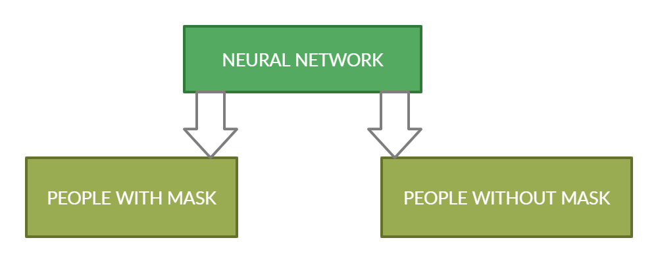

The above diagram shows the decision-making process which neural network will be performing.

Legislation regarding face mask in Canada:

Public health officials are requesting people to wear mask depending on rates of infection and transmission [5]. The use of face mask is mandatory by various jurisdictions in many indoor public spaces and even on public transportation. Even the public gatherings are restricted in some provinces depending upon the number of the active cases.

**CONVOLUTIONAL NEURAL NETWORK**

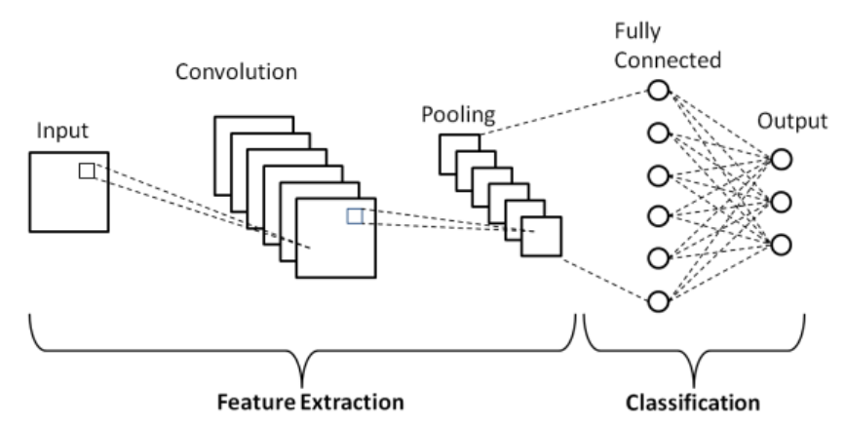

**ESSENTIAL LIBRARIES AND TOOLS REQUIRED**

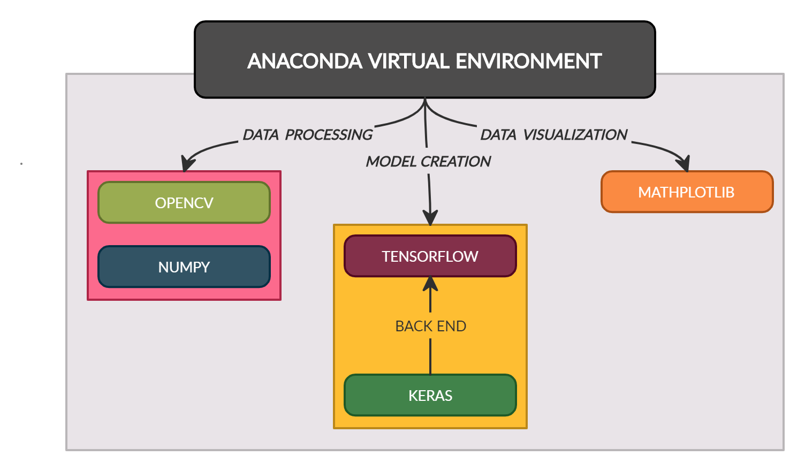

**PROPOSED ALGORITHM**

Our aim for the proposed solution of the Live mask detection system is to detect if the subject has worn mask or not from live feed. Proposed algorithm for the solution is as follows:

1] Train the neural network on the dataset and save the best trained CNN model.

2] Take the live feed from video source and split it into images

3] Apply classifier on the image to isolate area of interest [ i.e the face regions]

4] Apply preprocessing on the classified image.

5] Feed the image in the best trained CNN model and identify if the face is with mask or without mask.

**DATASET**

The data-source for this project is from **KAGGLE** prepared by **Omkar Gurav**. The data comprised a **total of 7553** augmented images with RGB channels. These are divided further into two sub-folders namely masked and non-masked images folder with **3725 images and 3825 images** respectively. We have gathered images from internet and added them to the existing dataset.

**CODE**

We tried two approaches to train the NN for this problem  
1] Training Convolutional neural network for mask detections from scratch.

2] Apply transfer learning on pretrained MobileNetV2 model

**METHOD 1**

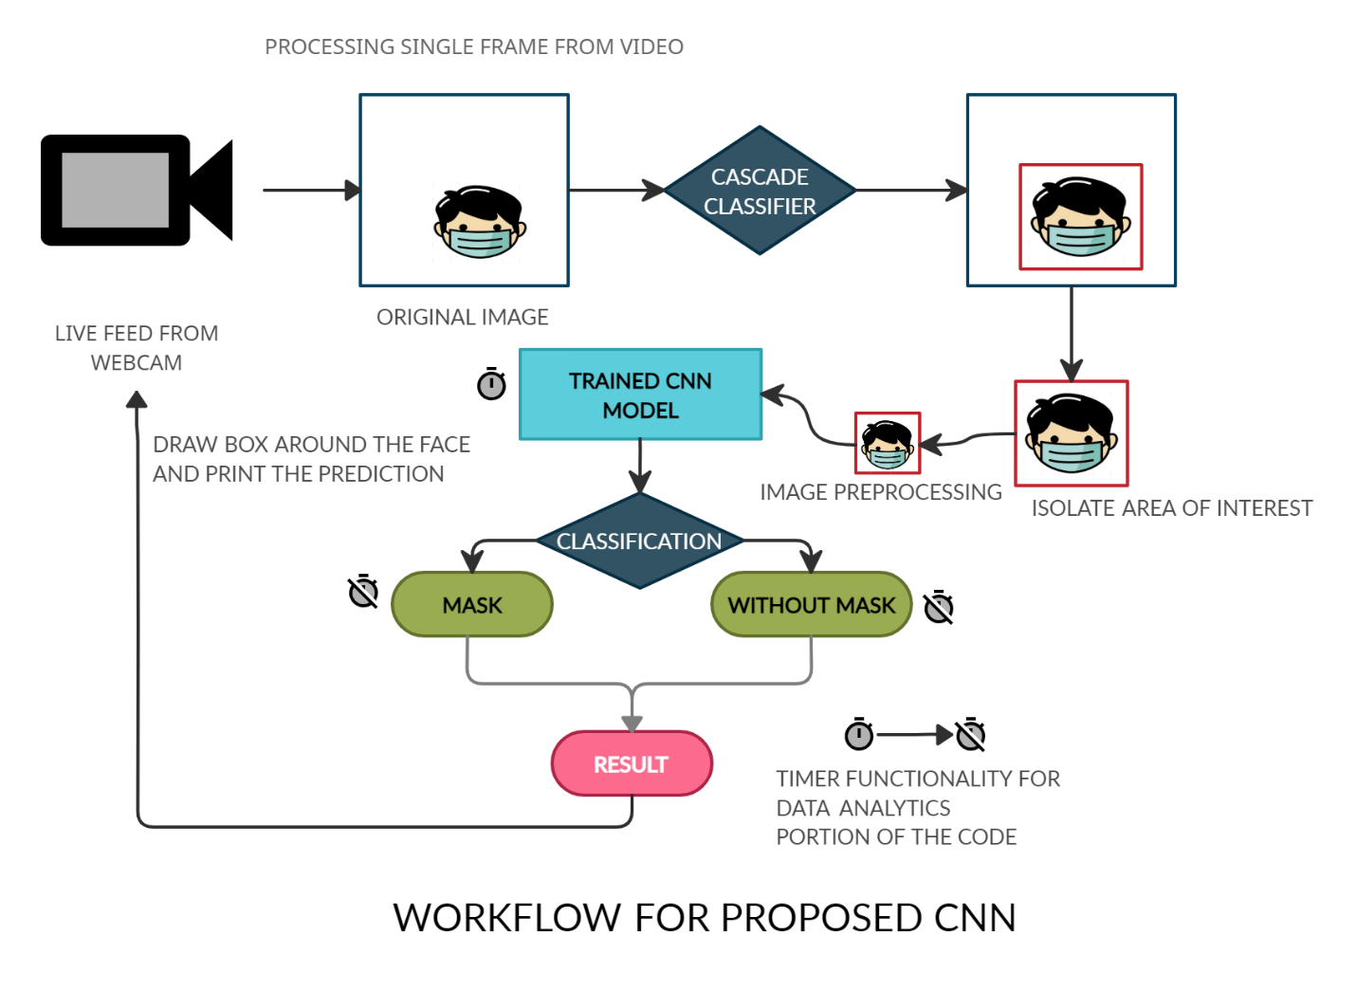

We solution can be divided into three stages:

1. **Stage 1:** The first stage is the data preprocessing and it is shown below:

**import** **cv2**,**os**

data_path='dataset'

categories=os.listdir(data_path)

labels=[i **for** i in range(len(categories))]

label_dict=dict(zip(categories,labels))

**print**(label_dict)

**print**(categories)

**print**(labels)

img_size=**100**

data=[]

target=[]

counter=**0**

**for** category in categories:

folder_path=os.path.join(data_path,category)

img_names=os.listdir(folder_path)

**for** img_name in img_names:

img_path=os.path.join(folder_path,img_name)

img=cv2.imread(img_path)

**print**(img_name)

counter=counter +**1**

**try**:

gray=cv2.cvtColor(img,cv2.COLOR_BGR2GRAY)

#Coverting the image into gray scale

resized=cv2.resize(gray,(img_size,img_size))

#resizing the gray scale into 100x100, since we need a fixed common size for all the images in the dataset

data.append(resized)

target.append(label_dict[category])

#appending the image and the label(categorized) into the list (dataset)

**except** **Exception** **as** e:

**print**('Exception:',e)

**print**(counter)

**import** **numpy** **as** **np**

data=np.array(data)/**255.0**

data=np.reshape(data,(data.shape[**0**],img_size,img_size,**1**))

target=np.array(target)

**from** **keras.utils** **import** np_utils

new_target=np_utils.to_categorical(target)

np.save('data',data)

np.save('target',new_target)

The above code converts the input image into a 100 * 100 greyscale images. The reason being that, we consider that in mask detection our main objective is not to identify the color of the mask rather we need to decrease the training time for our NN model. So, by removing the color and by resizing the original image we can focus on feature that helps us to identify required features for detection.  
  
**2)** **Stage 2:** In the second stage we used the pre-processed images from the first stage as an input for training our NN.

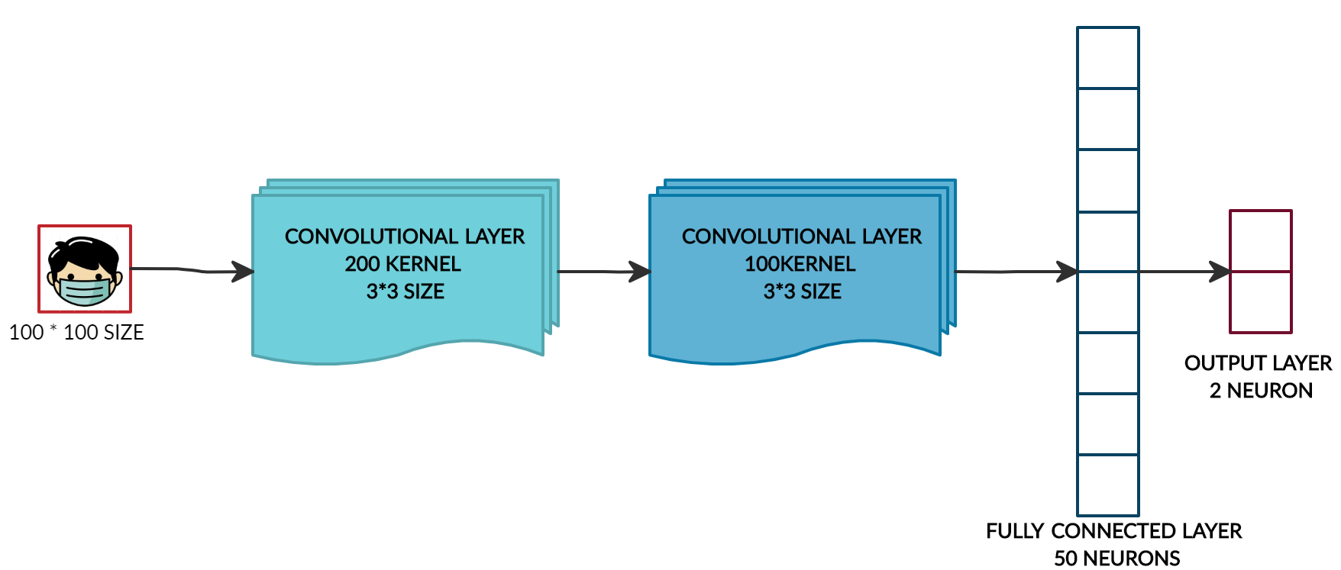

**import** **numpy** **as** **np**

data=np.load('data.npy')

target=np.load('target.npy')

**from** **keras.models** **import** Sequential

**from** **keras.layers** **import** Dense,Activation,Flatten,Dropout

**from** **keras.layers** **import** Conv2D,MaxPooling2D

**from** **keras.callbacks** **import** ModelCheckpoint

model=Sequential()

model.add(Conv2D(**200**,(**3**,**3**),input_shape=data.shape[**1**:]))

model.add(Activation('relu'))

model.add(MaxPooling2D(pool_size=(**2**,**2**)))

#The first CNN layer followed by Relu and MaxPooling layers

model.add(Conv2D(**100**,(**3**,**3**)))

model.add(Activation('relu'))

model.add(MaxPooling2D(pool_size=(**2**,**2**)))

#The second convolution layer followed by Relu and MaxPooling layers

model.add(Flatten())

model.add(Dropout(**0.5**))

#Flatten layer to stack the output convolutions from second convolution layer

model.add(Dense(**50**,activation='relu'))

#Dense layer of 64 neurons

model.add(Dense(**2**,activation='softmax'))

#The Final layer with two outputs for two categories

model.compile(loss='categorical_crossentropy',optimizer='adam',metrics=['accuracy'])

**from** **sklearn.model_selection** **import** train_test_split

train_data,test_data,train_target,test_target=train_test_split(data,target,test_size=**0.1**)

checkpoint = ModelCheckpoint('model{epoch:03d}.model',monitor='val_loss',verbose=**0**,save_best_only=True,mode='auto')

history=model.fit(train_data,train_target,epochs=**10**,callbacks=[checkpoint],validation_split=**0.2**)

The skeleton of the network is same as shown in figure. We have used Softmax function as an activation function because softmax functions performs best when we have to normalize the output and convert tensors/list from previous layer into weight sum probability whose total probability sum up to unity [ Best case scenarios binary classification tasks].linear and sigmoidal functions fails to achieve this.

**3)** **Stage 3:** Deployment of the model using live stream from WEBCAM as an input

**from** **keras.models** **import** load_model

**import** **cv2**

**import** **numpy** **as** **np**

**import** **tkinter**

**from** **tkinter** **import** messagebox

**import** **smtplib**

**from** **datetime** **import** datetime

**import** **matplotlib.pyplot** **as** **plt**

**import** **cv2**

#we load the best trained model

model = load_model('model-10.model')

labels_dict={**0**:'MASK',**1**:'NO MASK'}

color_dict={**0**:(**0**,**255**,**0**),**1**:(**0**,**0**,**255**)}

m_count=**0**

nm_count=**0**

m_list=[]

nm_list=[]

time_list=[]

counter=**0**

#start of the timer for the session

StartdateTimeObj = datetime.now()

#Enable live feed from the web camera

videocapture = cv2.VideoCapture(**0**)

scale_factor = **1.3**

**while** **1**:

#load haarcascade classifier

face_clsfr=cv2.CascadeClassifier('haarcascade_frontalface_default.xml')

source=cv2.VideoCapture(**0**)

ret,img=source.read()

gray=cv2.cvtColor(img, cv2.COLOR_BGR2GRAY)

#Segregate the faces using haarcascade classifier from live feed

faces=face_clsfr.detectMultiScale(gray,**1.3**,**5**)

**for** (x,y,w, h) in faces:

face_img=gray[y:y+w,x:x+w]

resized=cv2.resize(face_img,(**100**,**100**))

normalized=resized/**255.0**

reshaped=np.reshape(normalized,(**1**,**100**,**100**,**1**))

#feed a 100 by 100 grayscale image to the network

result=model.predict(reshaped)

label=np.argmax(result,axis=**1**)[**0**]

#Code to draw label face and predictions from model

cv2.rectangle(img,(x,y),(x+w,y+h),color_dict[label],**2**)

cv2.rectangle(img,(x,y-**40**),(x+w,y),color_dict[label],-**1**)

cv2.putText(img, labels_dict[label], (x, y-**10**),cv2.FONT_HERSHEY_SIMPLEX,**0.8**,(**255**,**255**,**255**),**2**)

#only update if face is detected with mask in a frame

**if**(label==**0**):

m_count = m_count+**1**

counter=counter + **1**

#only update if face is detected without mask in a frame

**if**(label==**1**):

nm_count = nm_count + **1**

counter=counter + **1**

**if** counter==**2**:

pltEndTime=datetime.now()

m_list.append(m_count)

nm_list.append(nm_count)

time_list.append(((StartdateTimeObj-pltEndTime).seconds))

counter = **0**

cv2.imshow('face', img)

k = cv2.waitKey(**30**) & **0xff**

**if**(k == **27**):

**break**

cv2.destroyAllWindows()

source.release()

#end of the time sequence for the session

EnddateTimeObj = datetime.now()

The In the stage 3 we have applied pre-train model on the live feed from webcam. Where there were no real time operations to be calculated for data analytics purpose, we have experienced a very high frame rate and our configuration was adequate to run the code. But as we enabled the analytics feature in the code, we experienced a medium frame rate that was at acceptable standards when we consider feature-frame rate trade-off.

**RESULTS OF PROPOSED NEURAL NETWORK:**

**Training Neural Network Plots**

Figure: plot of training accuracy and validation accuracy.

Figure: plot of training loss and validation loss.

We ran our neural network for some time with different combinations and results are shown below:

**Case 1)** In this case there were two people, one without mask and other with partially covered mask. It was critical for the neural network to distinguish between the partially covered and fully covered face condition. Our results shown that the neural network was able to discern such condition. It gave accurate result as shown below:

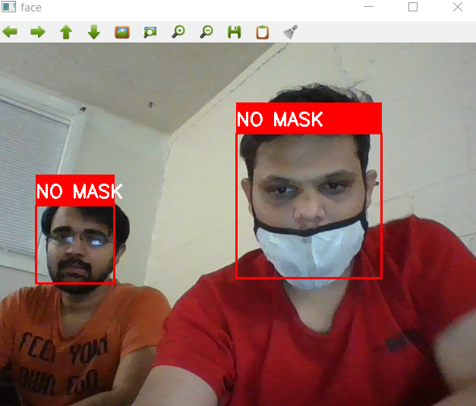

**Case 2)** In this case once again there were two people, one without mask looking into mobile and other with mask. The neural network gave accurate output for both the people and the result is shown below:

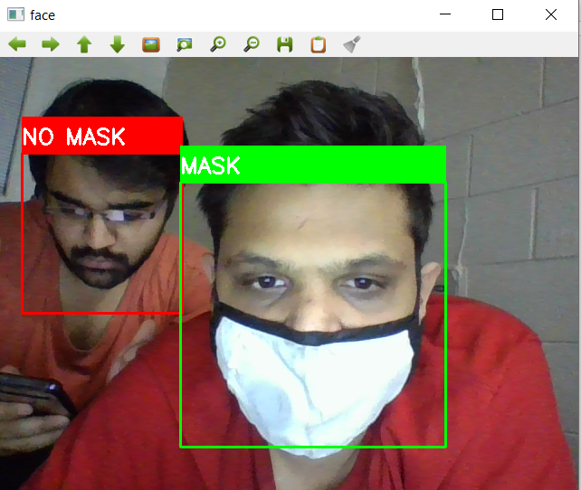

**Case3)** In this case the person was covering his face using his hands and neural network output was shown to be as a person without mask.

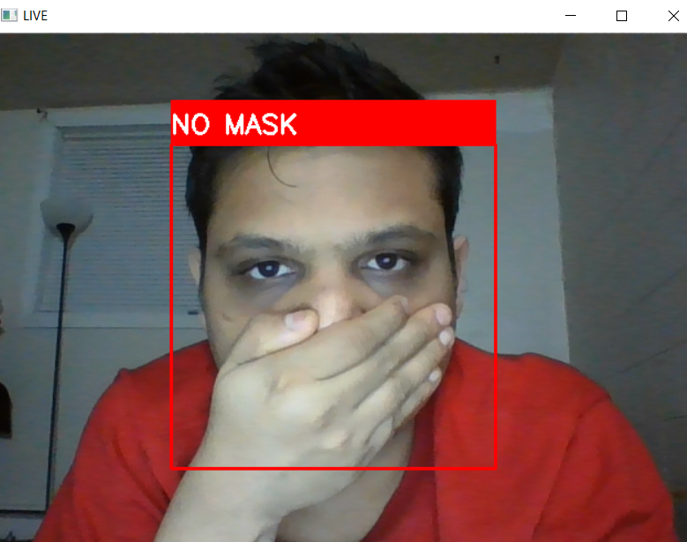

**D****ata analytics on the data gathered from predictions**

An auto-generated report is e-mailed to the concerned authority at the end of the session for mask detections code. Report comprises of the following sections.



|  |  |  |
| --- | --- | --- |
|  | We can infer from graph that how many people were detected with mask  at a given time range. Also, total people with mask detected during this session. | |
|  |  | |
|  | | We can inference from graph that how many people were detected without mask  at a given time range. This graph will help us to find time slots where security must enforce laws stringently. |
|  | In Ideal case if all people are wearing mask this plot should be a horizontal line but if people without mask are detected it will spike. This can be helpful in real time monitoring | |

**Current Benchmark method: MobilenetV2**

This model was developed by the Google researchers and they had optimized this model for the mobile devices. This was computationally less expensive as it involved reduction in parameters and mathematical operations. This model - MobileNet uses depthwise separable convolutions, which comprises a depthwise and a pointwise convolution after one another.

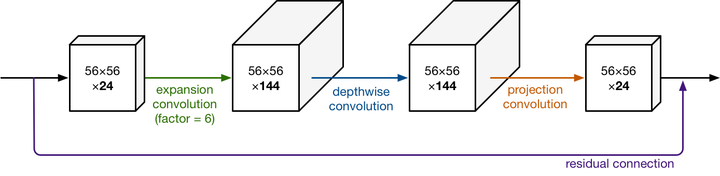

**Reinforcement learning Code for MobilenetV2**

The below snippet modifies the top layer of MobileNetV2 to allow us to solve mask detection problem. We have added 3 layers dense layer(128), Dropout layer(0.5) and Dense layer(2). Here we have changed the same preprocessing code we have used in our custom NN model step 1 to create dataset of 224*224 grayscale images and feed it in NN for training [checkout github link for complete code].

baseModel = MobileNetV2(weights="imagenet", include_top=False,

input_shape=(**224**, **224**, **3**))

# construct the head of the model that will be placed on top of the

# the base model

headModel = baseModel.output

headModel = AveragePooling2D(pool_size=(**7**, **7**))(headModel)

headModel = Flatten(name="flatten")(headModel)

headModel = Dense(**128**, activation="relu")(headModel)

headModel = Dropout(**0.5**)(headModel)

headModel = Dense(**2**, activation="softmax")(headModel)

model = Model(inputs=baseModel.input, outputs=headModel)

**for** layer in baseModel.layers:

layer.trainable = False

**Results of benchmark method – MobilenetV2**

We ran MobilenetV2 neural network with different combinations and results are shown below.

**Case 1)** In this case there was a person with partially covered mask and MobilenetV2 was able to conclude that it is a no_mask condition with 99.97% accuracy.

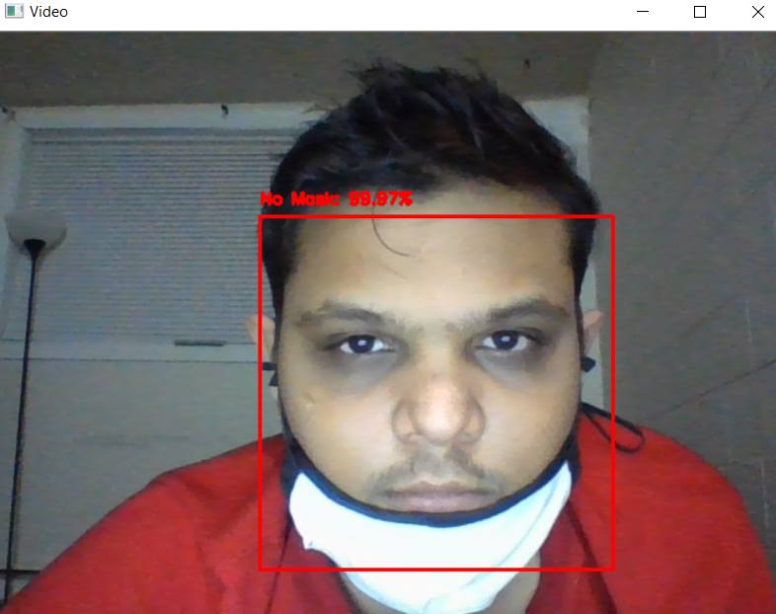

**Case 2)** In this case there was a person with fully covered mask and MobilenetV2 was able to conclude that it is mask condition with 99.85% accuracy.

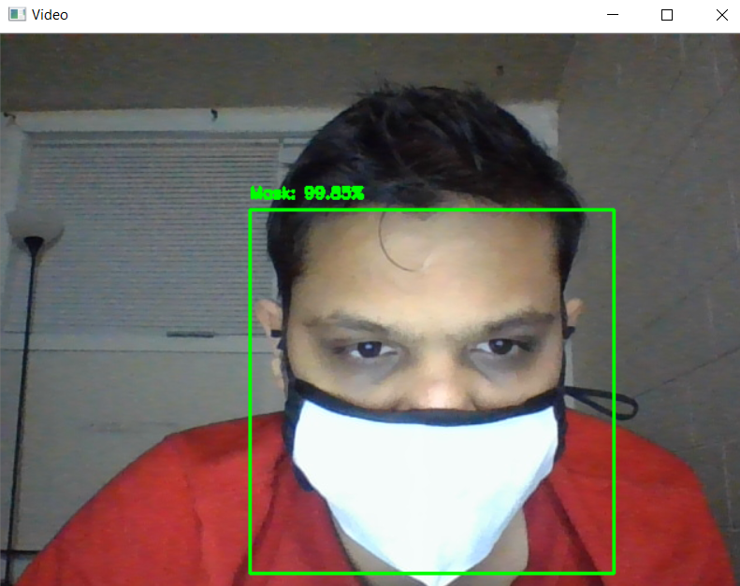

**Case3)** In this case the person was covering his face using his hands and MobilenetV2 output was shown to be as a person without mask.

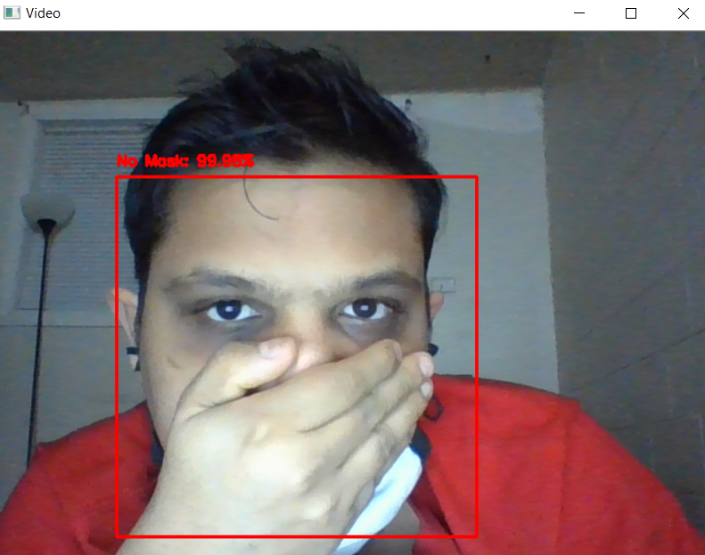

**TRAINING PLOTS - REINFORCEMENT LEARNING MOBILENETV2**

Figure: plot of training accuracy and validation accuracy.

Figure: plot of training loss and validation loss.

**Comparison proposed neural network VS MobilenetV2**

The comparison between our proposed neural network and benchmark – MobilenetV2 is tabulated below:

|  |  |  |  |
| --- | --- | --- | --- |
| **Sr.** | **Parameter** | **Proposed neural network** | **Benchmark – Mobilenetv2** |
| 1 | **Number of epochs** | 10 | 10 |
| 2 | **Average training time for each epoch** | ***Approximately 43 seconds*** | ***Approximately 383 seconds*** |
| 3 | **Best training accuracy** | ***97.98%*** | ***93.34%*** |
| 4 | **Result for fully covered condition** | Detected the mask | Detected the mask |
| 5 | **Result for partially covered condition** | Detected the no mask condition | Detected the no mask condition |
| 6 | **Result for face covered with hands** | Detected the no mask condition | Detected the no mask condition |

**Future Work**

We would like to use stacking approach in machine learning for further developing our custom

model. Using our custom pretrained model with other model to detect if user has worn mask partially and which part of his face is exposed.

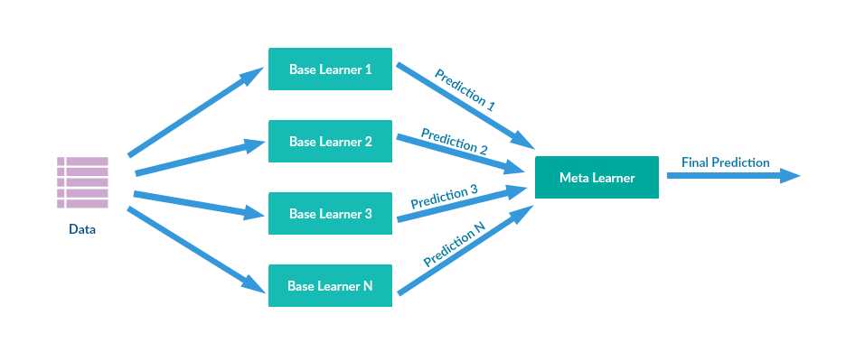

**GITHUB LINK**

* **https://github.com/Dhaval-B-Patel/AANN**

**REFERENCES**

1. "Convolutional Neural Networks." Convolutional Neural Networks, [www.doc.ic.ac.uk/~jce317/introduction-cnns.html#top](http://www.doc.ic.ac.uk/~jce317/introduction-cnns.html#top).
2. Phung, V.H.; Rhee, E.J. A Deep Learning Approach for Classification of Cloud Image Patches on Small Datasets. J. Inf. Commun. Converg. Eng. 2018, 16, 173–178, doi:10.6109/jicce.2018.16.3.173.
3. "Understanding of Convolutional Neural Network (CNN) — Deep Learning." Understanding of Convolutional Neural Network (CNN) — Deep Learning, [medium.com/@RaghavPrabhu/understanding-of-convolutional-neural-network-cnn-deep-learning-99760835f148](mailto:medium.com/@RaghavPrabhu/understanding-of-convolutional-neural-network-cnn-deep-learning-99760835f148).
4. "Convolutional neural network." Convolutional neural network - Wikipedia, en.wikipedia.org/wiki/Convolutional_neural_network.
5. "Provincial and territorial resources for COVID-19." COVID-19: Non-medical masks and face coverings - Canada.ca, [www.canada.ca/en/public-health/services/diseases/2019-novel-coronavirus-infection/symptoms/provincial-territorial-resources-covid-19.html](http://www.canada.ca/en/public-health/services/diseases/2019-novel-coronavirus-infection/symptoms/provincial-territorial-resources-covid-19.html).
6. Gurav, Omkar. "Face Mask Detection Dataset." Face Mask Detection Dataset | Kaggle, [www.kaggle.com/omkargurav/face-mask-dataset](http://www.kaggle.com/omkargurav/face-mask-dataset).
7. How to interpret “loss” and “accuracy” for a machine learning, intellipaat.com/community/368/how-to-interpret-loss-and-accuracy-for-a-machine-learning-model.
8. MobileNetV2: Inverted Residuals and Linear Bottlenecks, towardsdatascience.com/mobilenetv2-inverted-residuals-and-linear-bottlenecks-8a4362f4ffd5.
9. Hollemans, Matthijs. https://machinethink.net/blog/mobilenet-v2/.
10. Vinitha and Velantina . "COVID-19 FACEMASK DETECTION WITH DEEP LEARNING AND COMPUTER VISION." International Research Journal of Engineering and Technology (IRJET).
11. Setunga, Supun. Stacking in Machine Learning, medium.com/@supun.setunga/stacking-in-machine-learning-357db1cfc3a